Lab 7: Access control vulnerabilities - Privilege escalation
Objective:
- This lab aims to assess knowledge of security best practices and measures that can be adopted to mitigate the risk of privilege escalation.
In this lab, students need to:
- Answer the following questions:
  - In the context of privilege escalation, what is the difference between vertical and horizontal privilege escalation, and can you give an example of each?
  - What are some effective strategies or practices that can be implemented to prevent privilege escalation vulnerabilities in a system?
- Perform challenge:
  - User ID controlled by request parameter
- Explain and capture all steps (full windows screen capture).

Submit a report addressing all the questions mentioned above in either PDF or Markdown format. Additionally, include a video demonstrating the detailed process of your work to ensure the authenticity of your lab exercise.
The report file name must be Class_YourStudentID _YourName_Lab7

User ID controlled by request parameter
This screenshot shows Burp Suite capturing HTTP requests while the user browses the lab website. In the HTTP history, we can see a request related to account or user information that includes a user ID parameter sent from the browser to the server. Because this ID is part of the request, it means the application relies on client-supplied data to identify which user account to access. An attacker can intercept this request and modify the ID value to another number. If the server does not properly check authorization, it will return another user’s data, demonstrating a horizontal privilege escalation (IDOR) vulnerability.
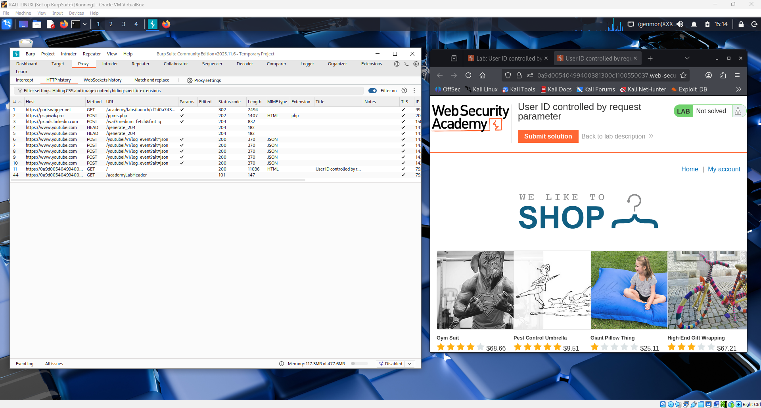

This image shows the login page of the lab website while Burp Suite is running in the background capturing HTTP traffic. The user is entering credentials to access their account, which will create an authenticated session. After login, the browser will send requests that include user-related parameters, such as a user ID. These requests can be intercepted in Burp Suite to analyze how the application identifies the logged-in user. This step is important because it allows us to observe whether the application uses secure session control or insecure user-controlled parameters.
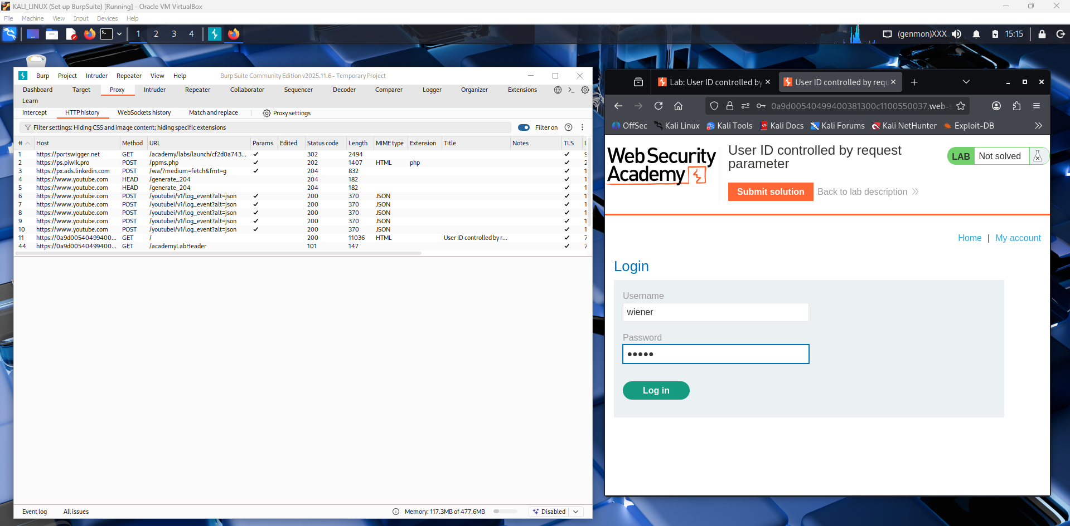

This screenshot shows the My Account page after login, displaying the username and API key. Burp Suite captures the request used to load this data from the server. The request likely includes a user ID parameter that identifies which account information to return. If this value is changed and another user’s data is shown, it demonstrates an IDOR (horizontal privilege escalation) vulnerability.
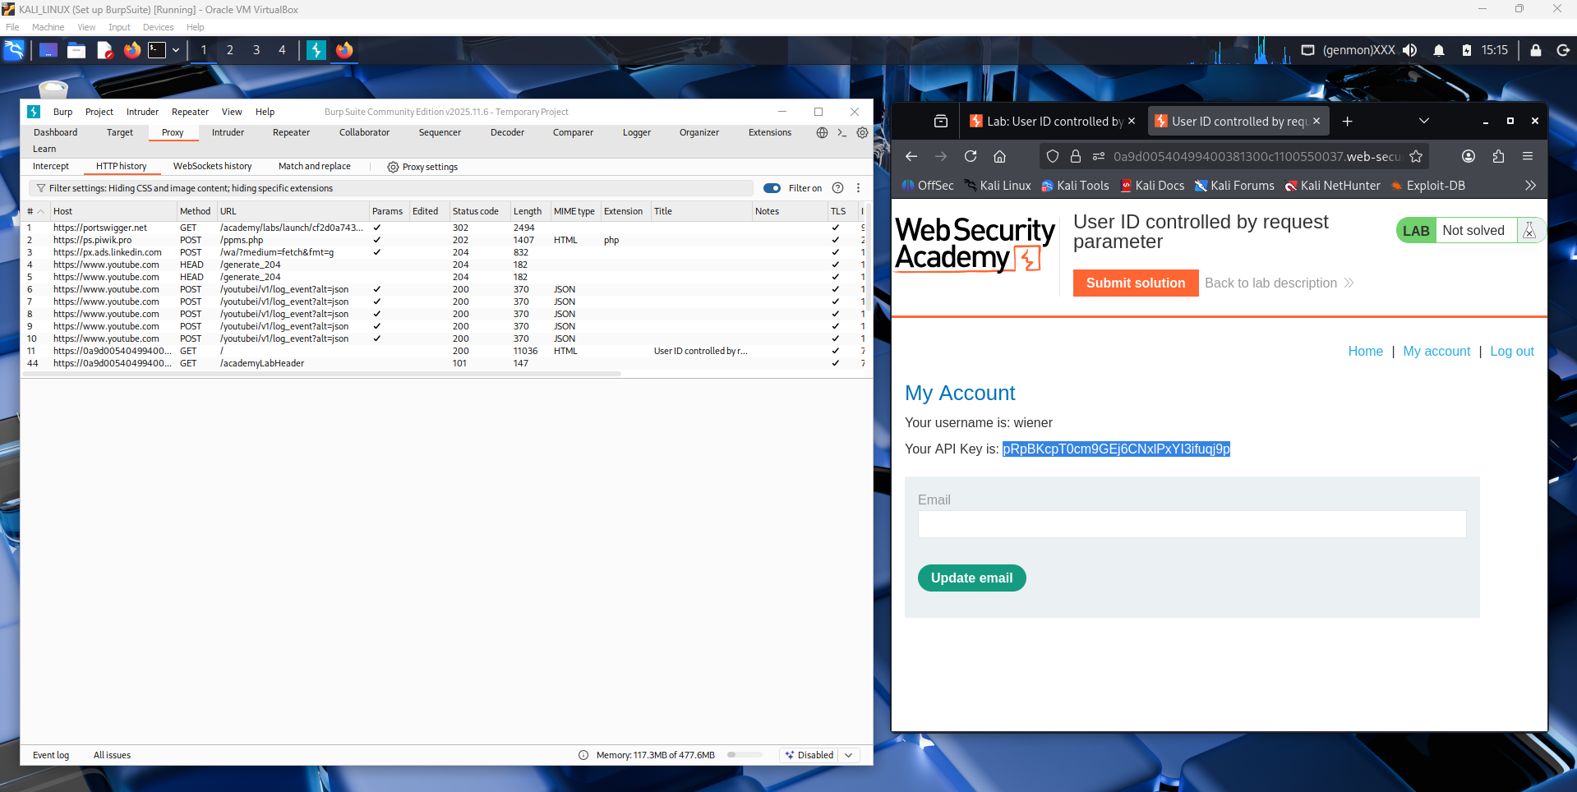
This screenshot shows a request intercepted in Burp Suite that loads the /my-account page. The request includes a parameter (such as an ID value) that tells the server which user’s account data to display. Since this value is sent from the browser, it can be modified before forwarding the request. If changing it returns another user’s account details, it proves a User ID controlled by request parameter (IDOR) vulnerability.
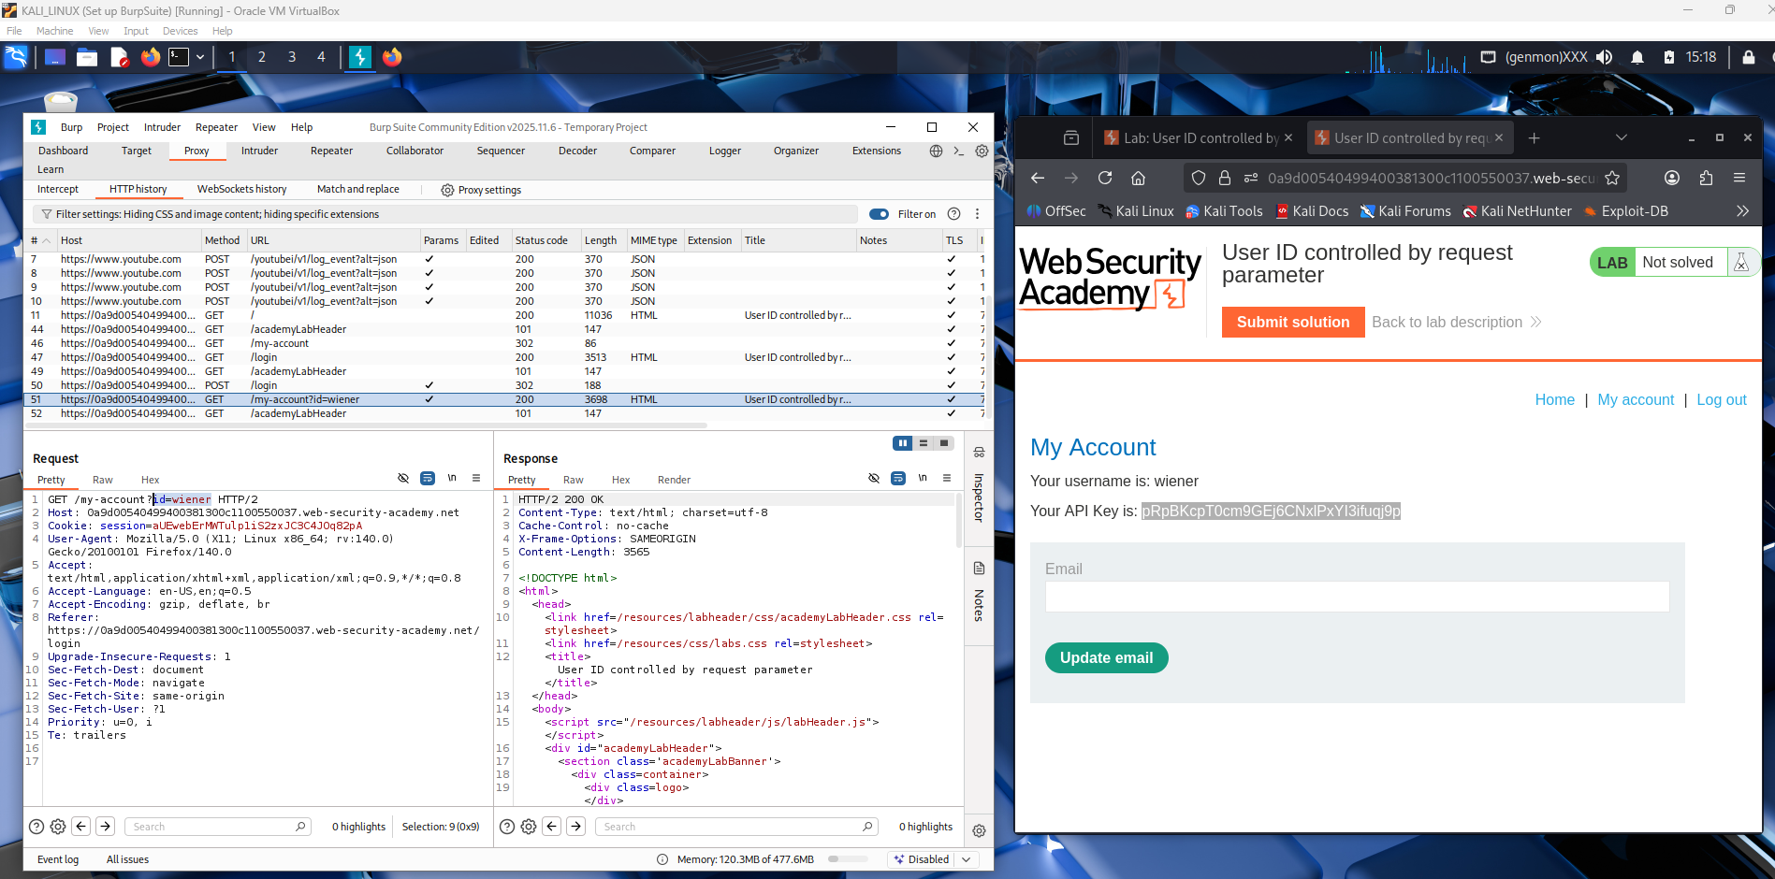
This screenshot shows the request being analyzed in Burp Repeater after being captured. The response contains account details such as the username and API key, which belong to a specific user. The Inspector panel highlights a user-related value that can be edited before resending the request. This demonstrates that the application relies on a user-controlled parameter instead of secure session validation. Modifying this value can allow access to another user’s data, confirming an IDOR vulnerability.
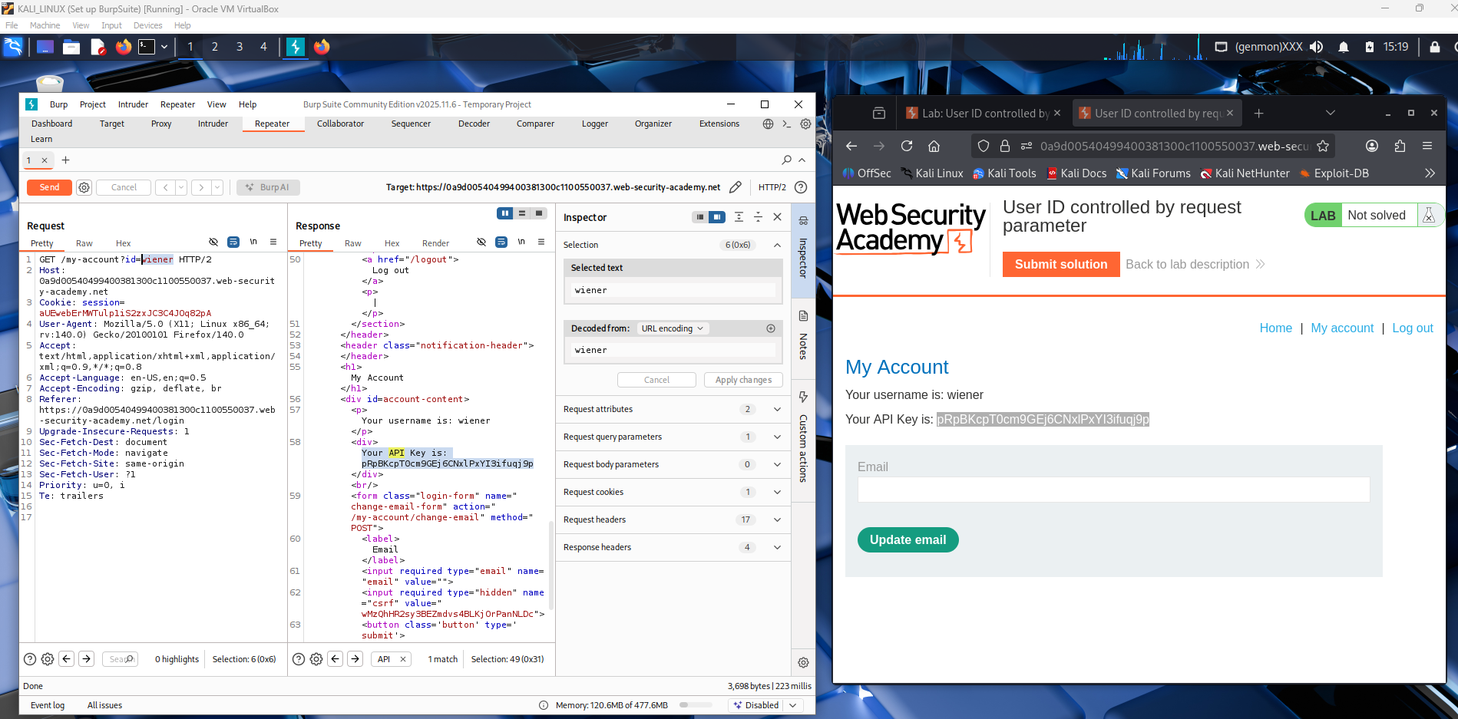
This screenshot shows the request in Burp Repeater after the user ID value has been modified from one user to another (e.g., to carlos). The server response now displays account information and an API key belonging to this different user. This proves that the application accepts the changed ID without verifying ownership. As a result, one user can access another user’s account data, demonstrating a horizontal privilege escalation (IDOR) vulnerability.
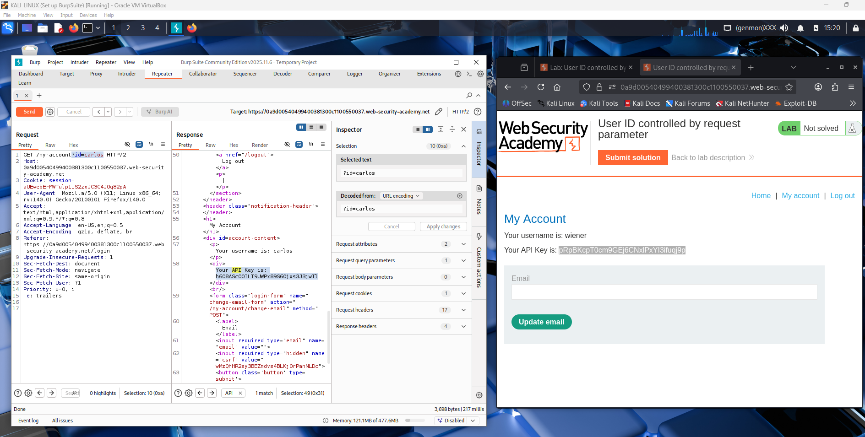
This screenshot shows the final step where the attacker uses the API key obtained from another user’s account. After modifying the user ID to carlos, the response revealed Carlos’s API key. That key is then submitted in the lab’s answer box to solve the challenge. This confirms that sensitive data from another account was accessible due to missing authorization checks. It demonstrates a successful IDOR-based horizontal privilege escalation attack.
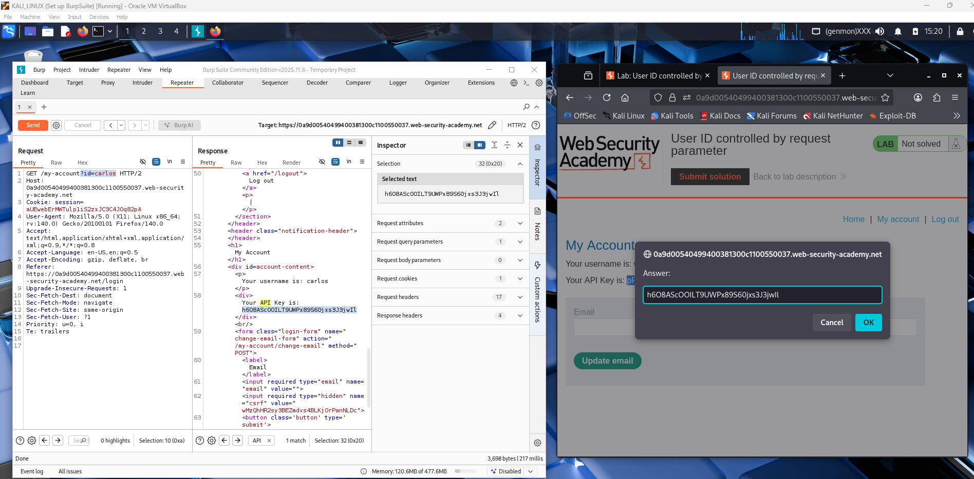
This screenshot shows the lab marked as Solved after submitting the API key obtained from another user’s account. Burp Repeater still displays the modified request where the user ID was changed to access carlos’s data. The successful response proves the server did not verify that the logged-in user owned the requested account. This confirms a User ID controlled by request parameter (IDOR) vulnerability leading to horizontal privilege escalation.
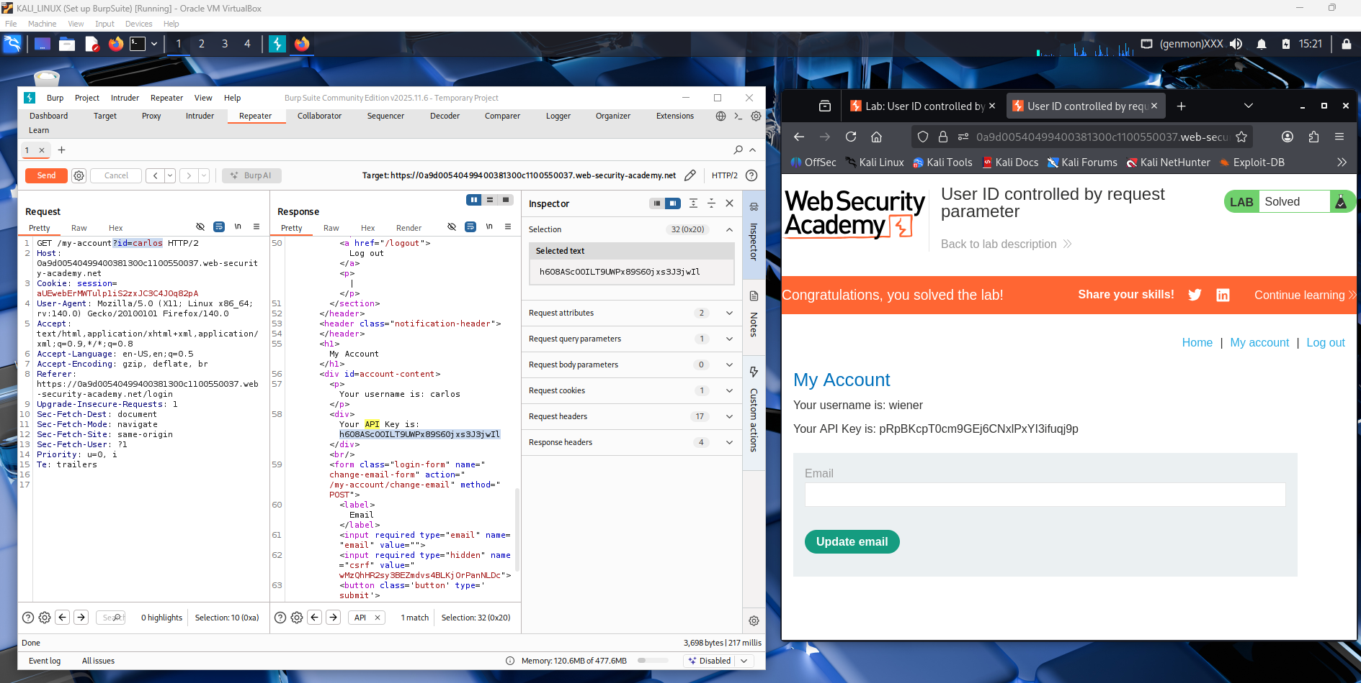
Conclusion:
Privilege escalation vulnerabilities occur when a system fails to properly enforce authorization rules. Vertical privilege escalation happens when a user gains higher permissions than intended, such as a normal user accessing an administrator panel and controlling system settings. In contrast, horizontal privilege escalation occurs when a user accesses another user’s data at the same privilege level, such as changing a user_id parameter to view another customer’s account information. Both types result from weak access control mechanisms.
To prevent privilege escalation, systems must enforce strict server-side authorization checks for every request and never trust client-controlled parameters. Using session-based identity management, applying the principle of least privilege, and implementing role-based access control (RBAC) help limit user capabilities. Developers should also use indirect object references, perform secure coding practices, and conduct regular security testing such as penetration testing and code reviews. Together, these measures reduce the risk of unauthorized access and protect sensitive data.

